Do2015 HIC Vendor Scorecard Results

Overview

In its effort to learn more about the effectiveness and value of its vendors, the State of Hawai‘i put forth this survey for the State’s portal manager, Hawaii Information Consortium (HIC). An online survey was distributed to current projects and projects under maintenance (111 agency contacts for the 37 of the HIC projects).

The survey period began on November 3, 2015, and extended to November 18, 2015. Some of the agency contacts are working on multiple projects with HIC. They were asked to complete a survey for each of those projects. There were 22 responses, which equates to about a 20 percent participation rate. The respondents were also asked to share their comments about HIC. That feedback is included at the end of this report.
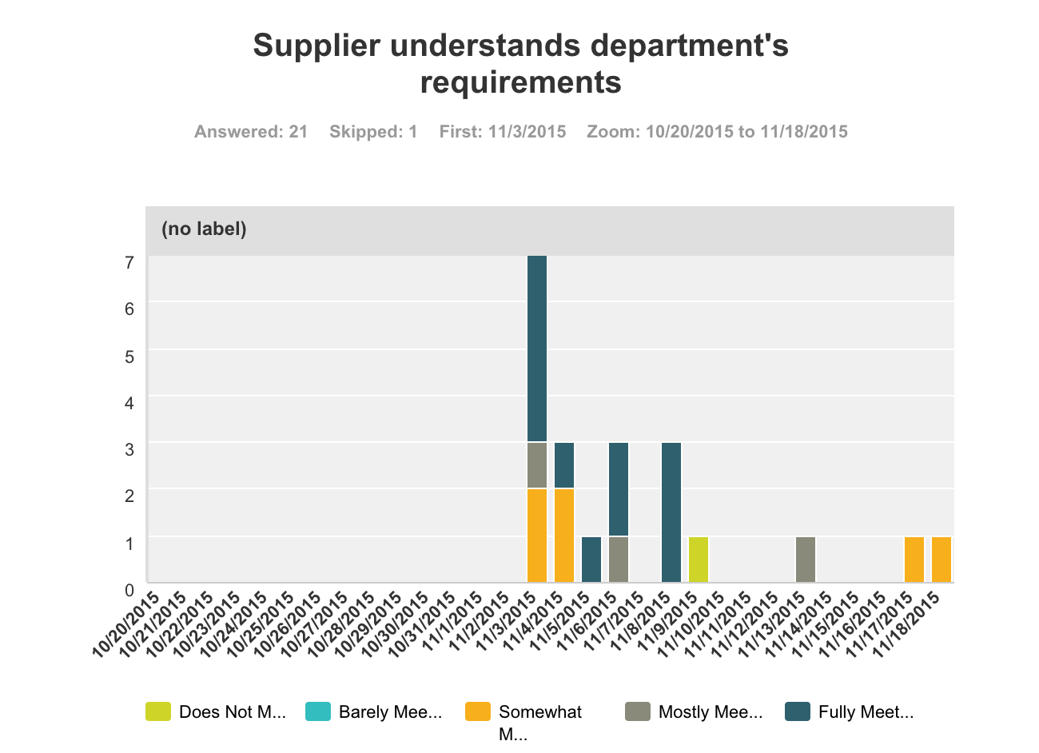
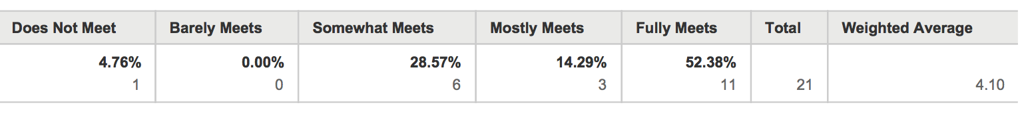

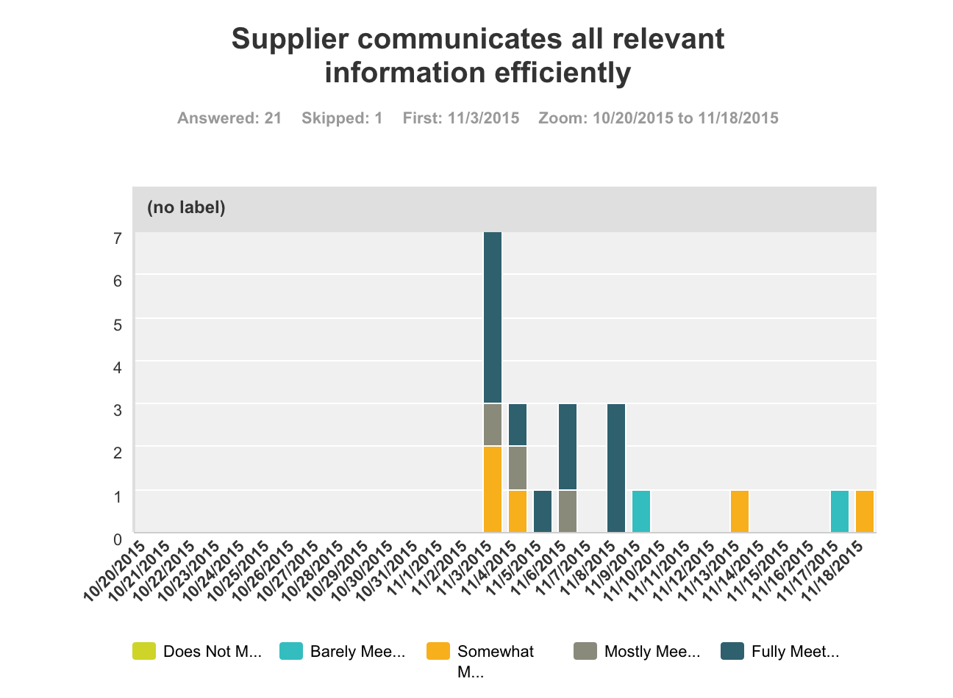

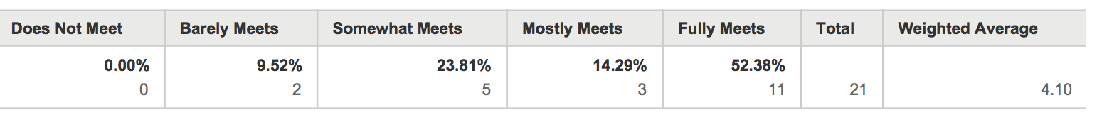

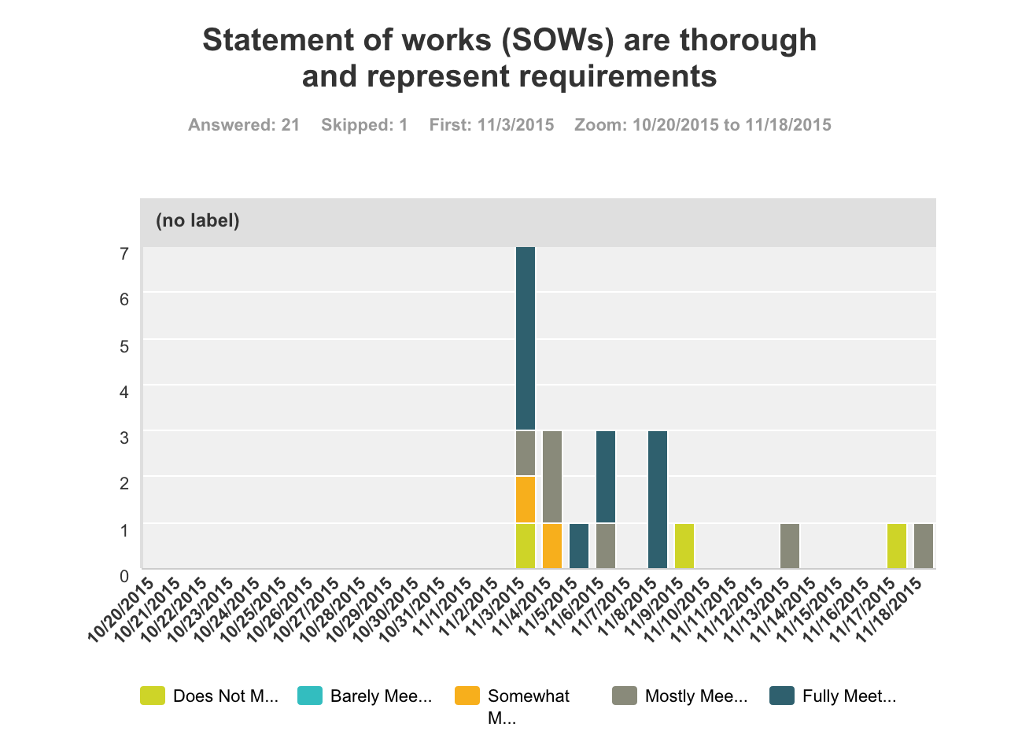

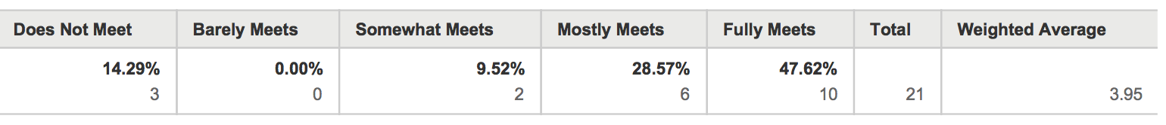

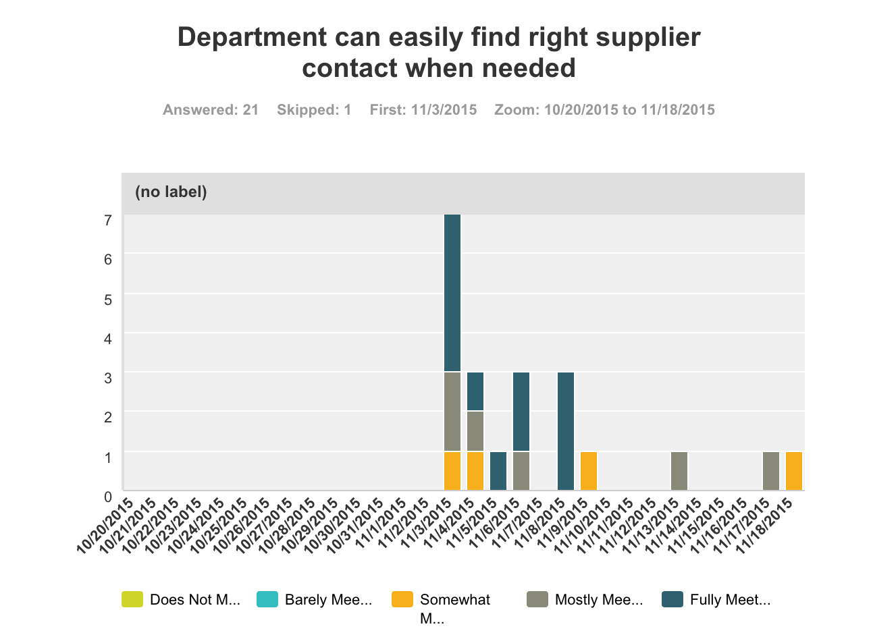

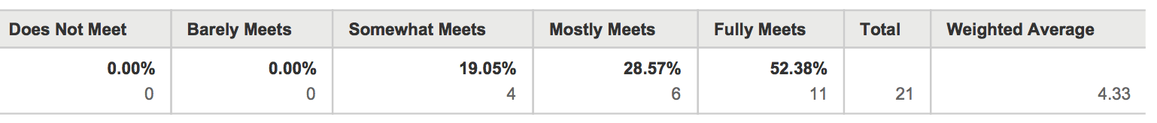

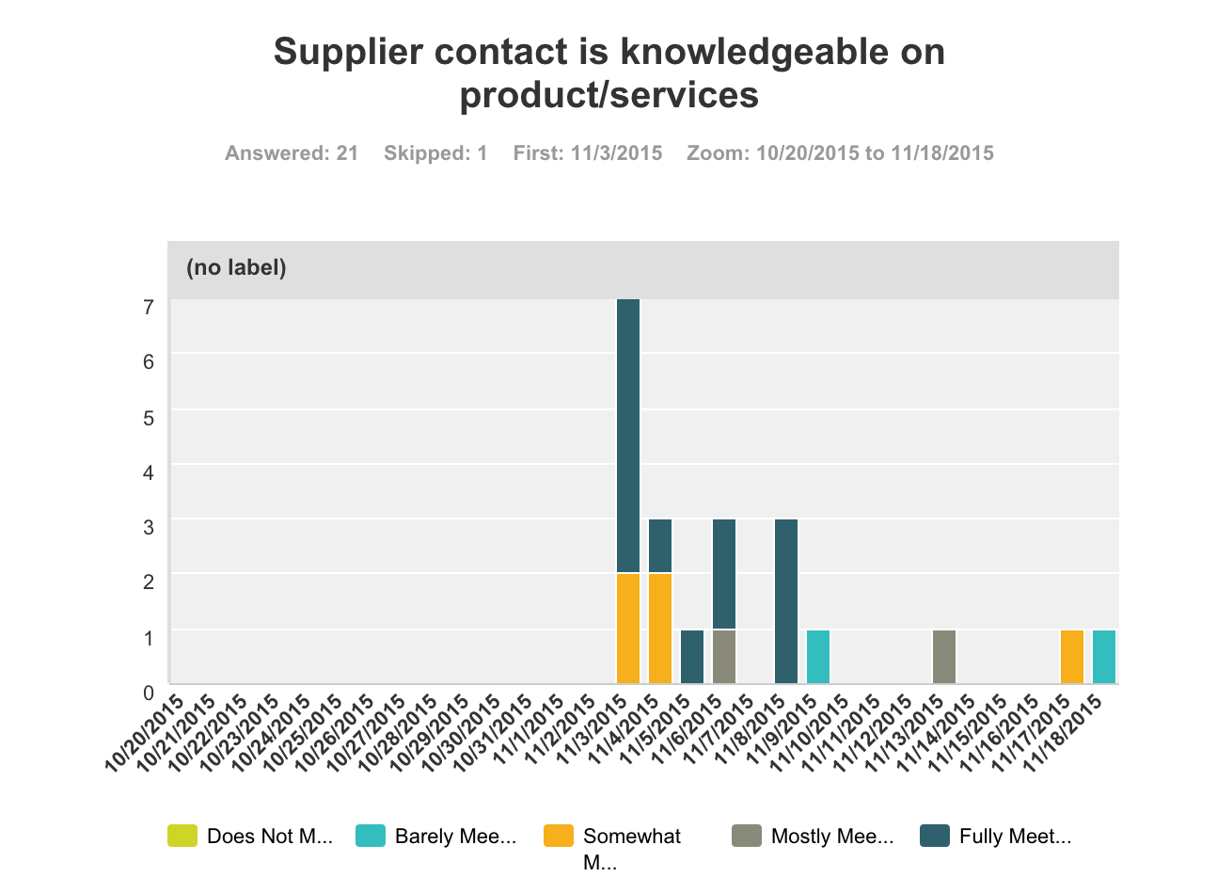

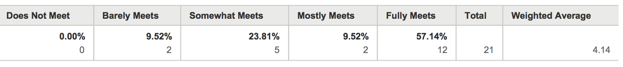

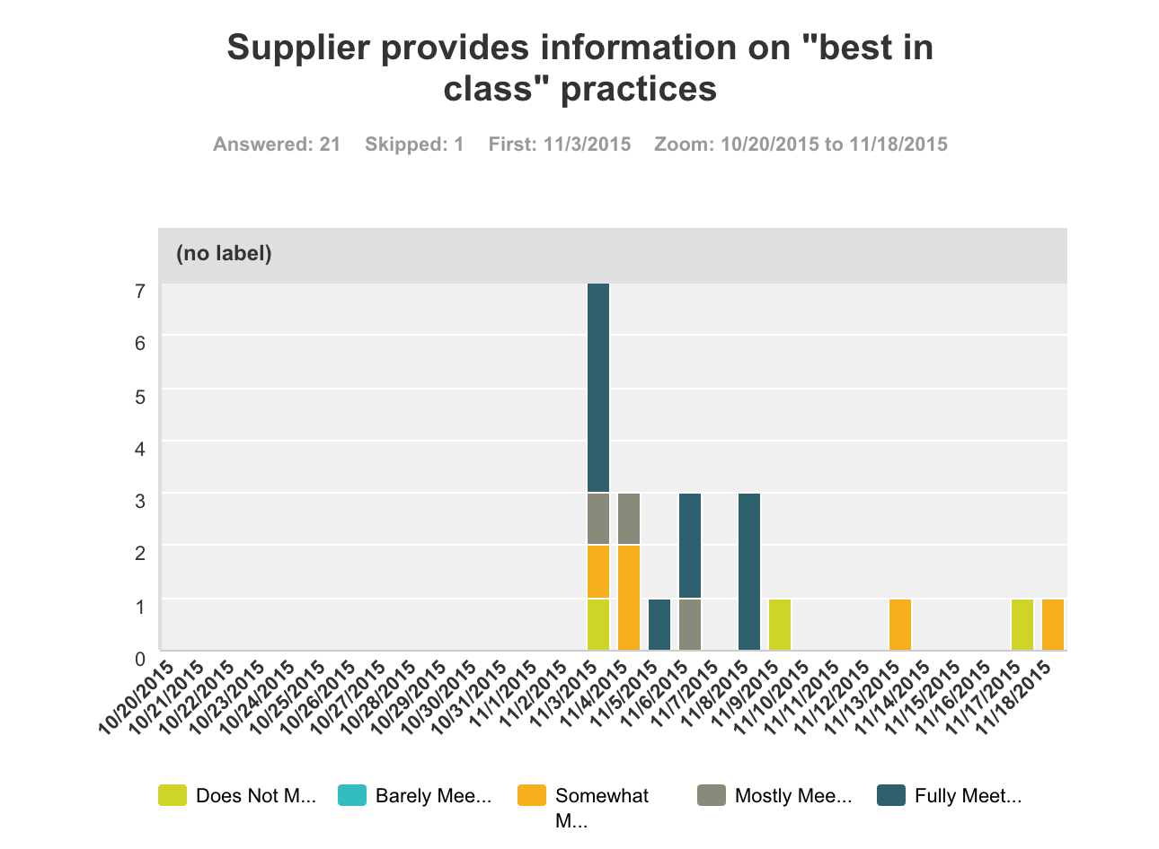

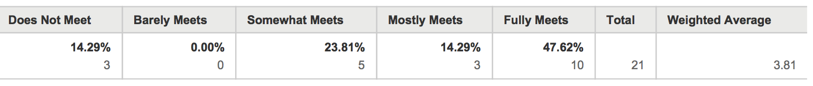

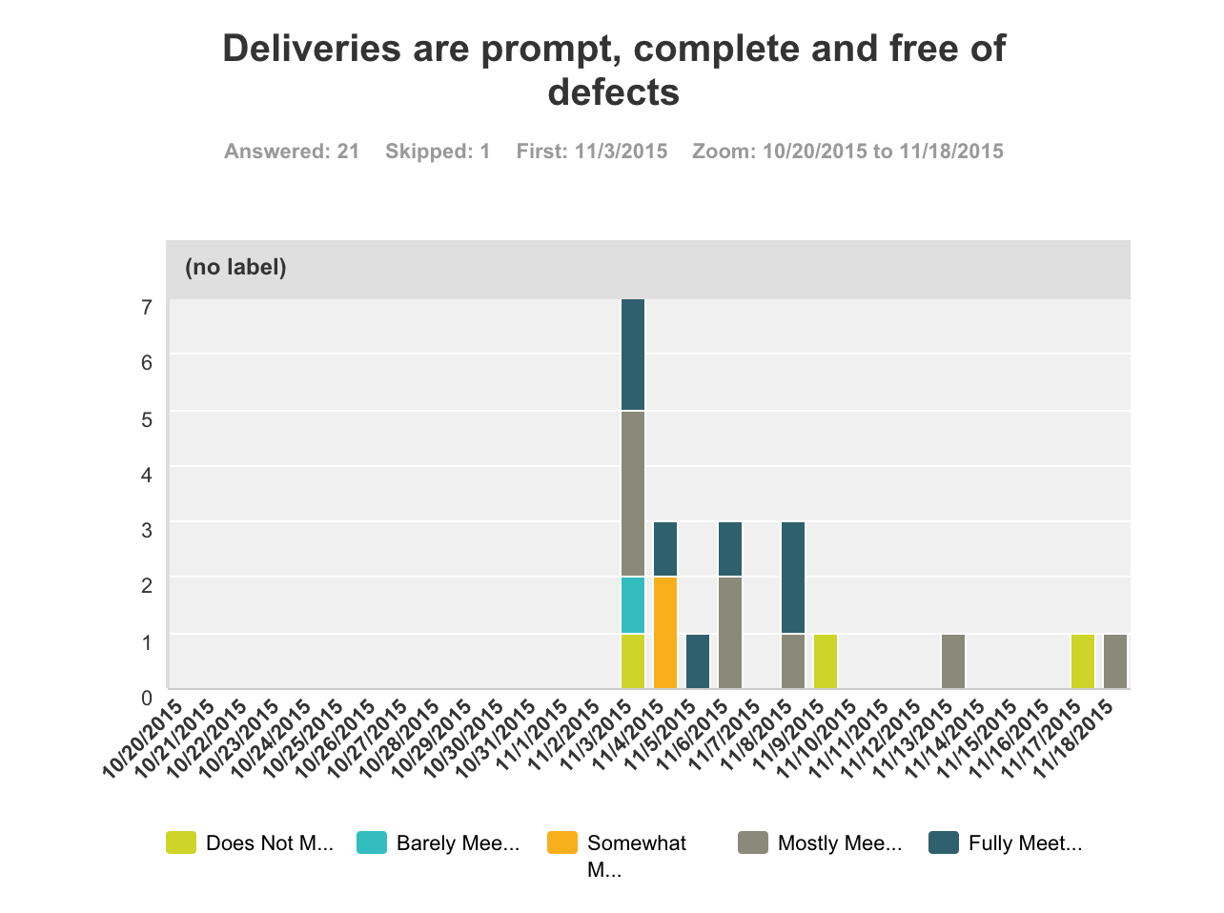

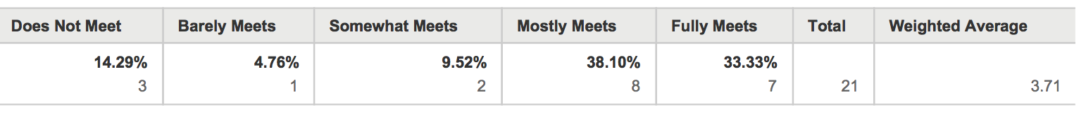

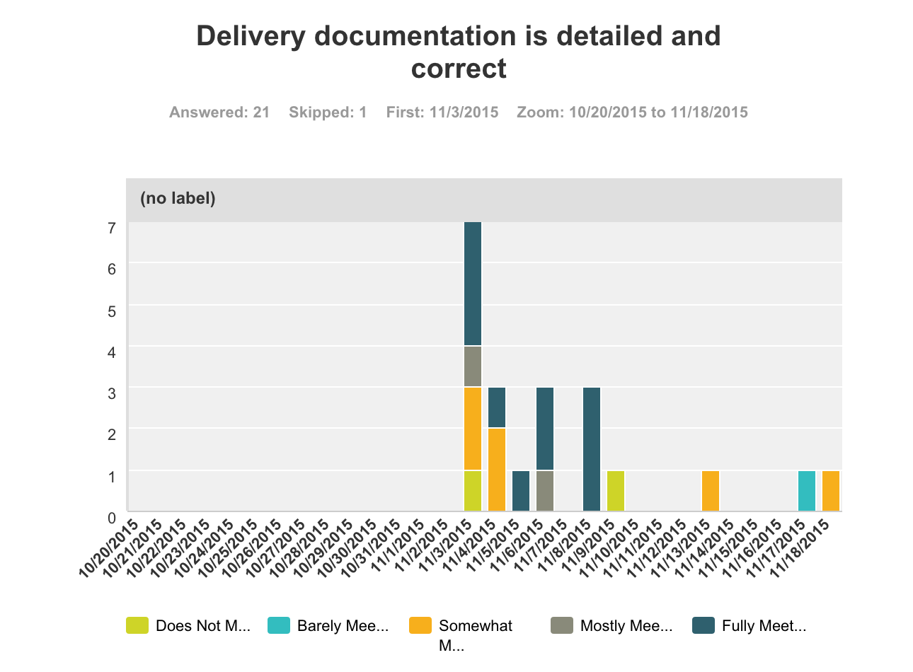

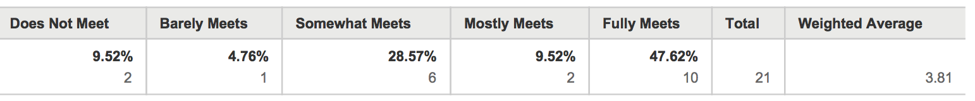

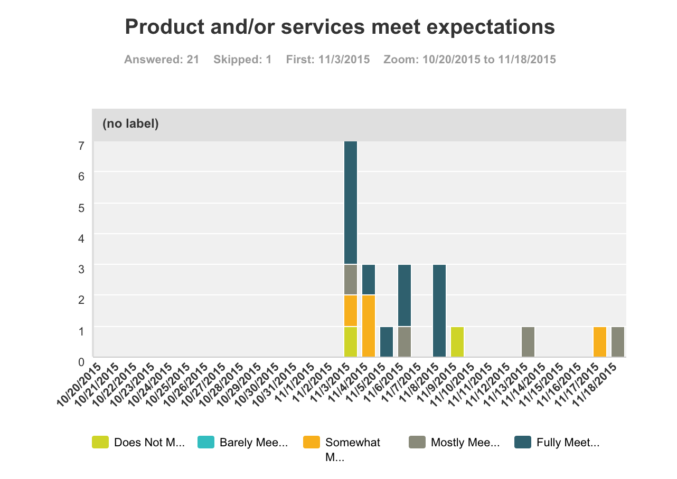

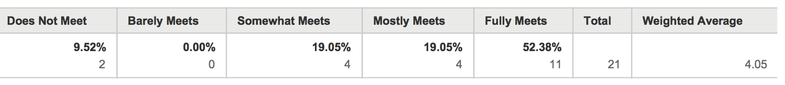

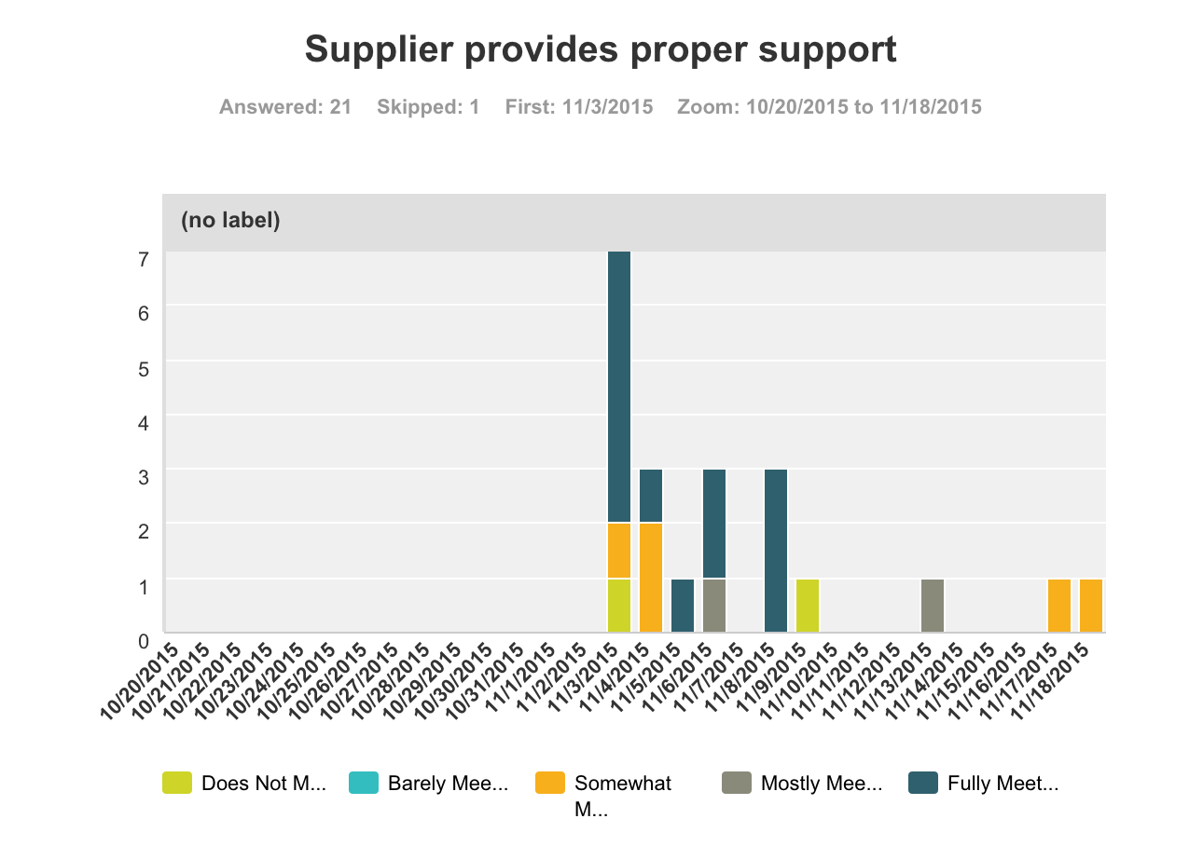

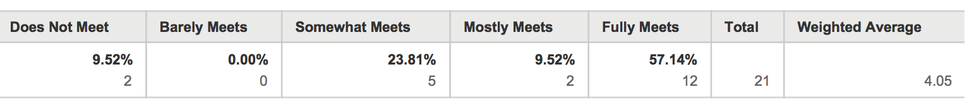

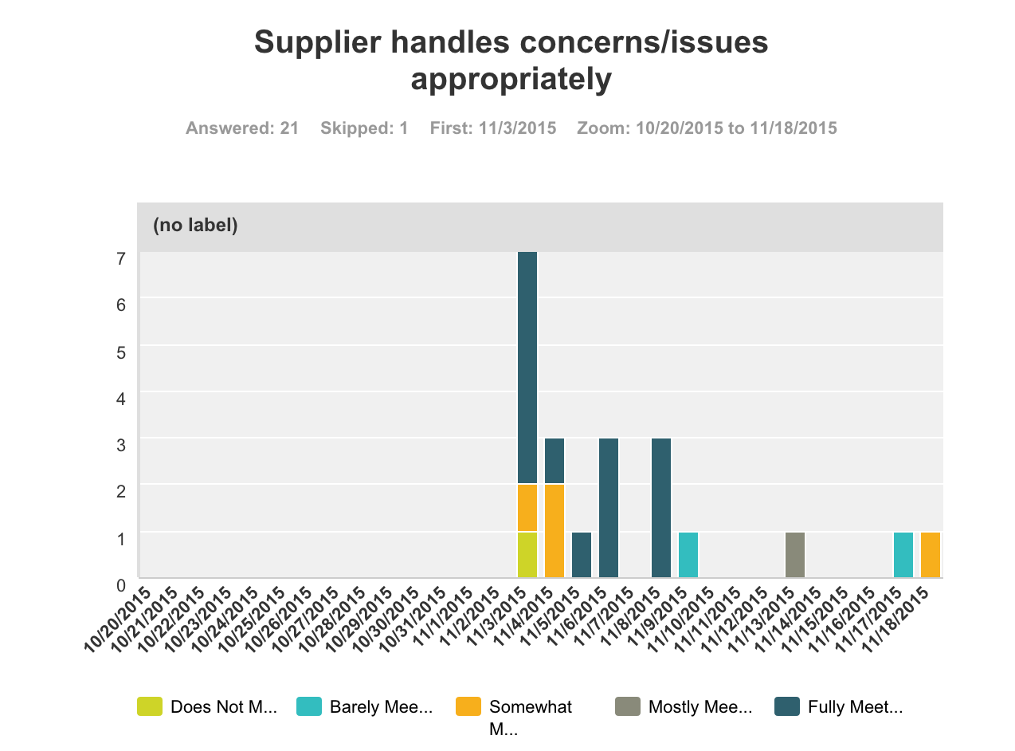

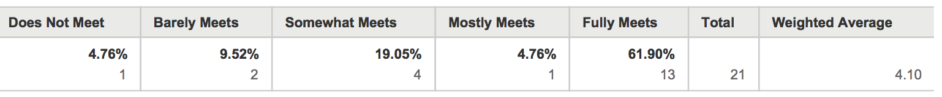

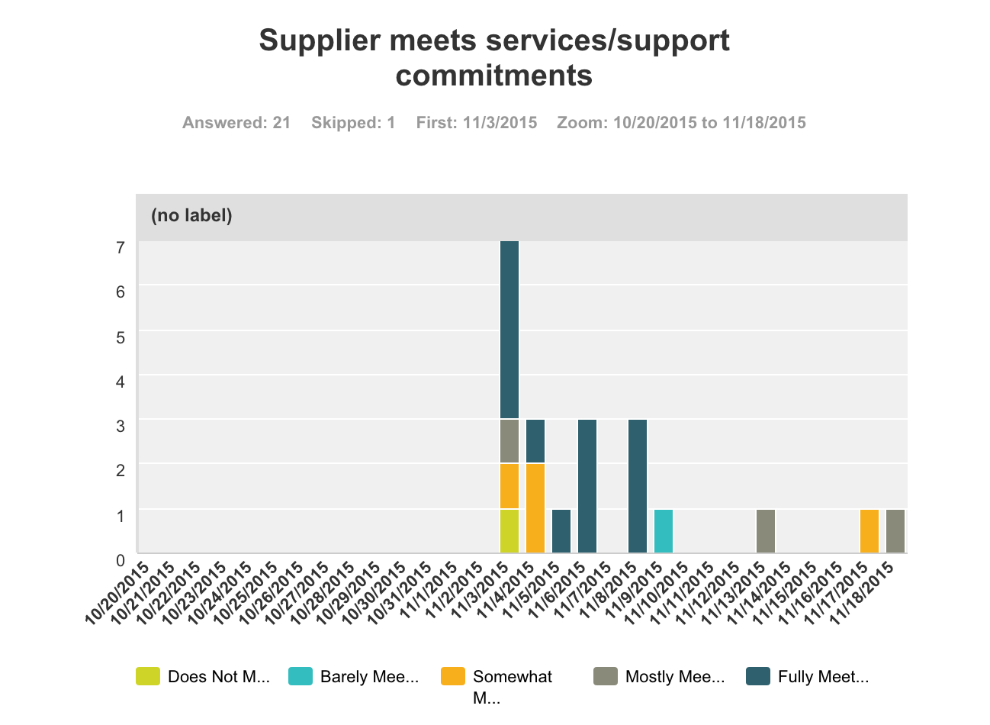

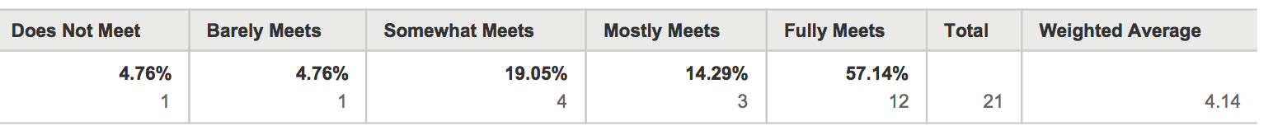

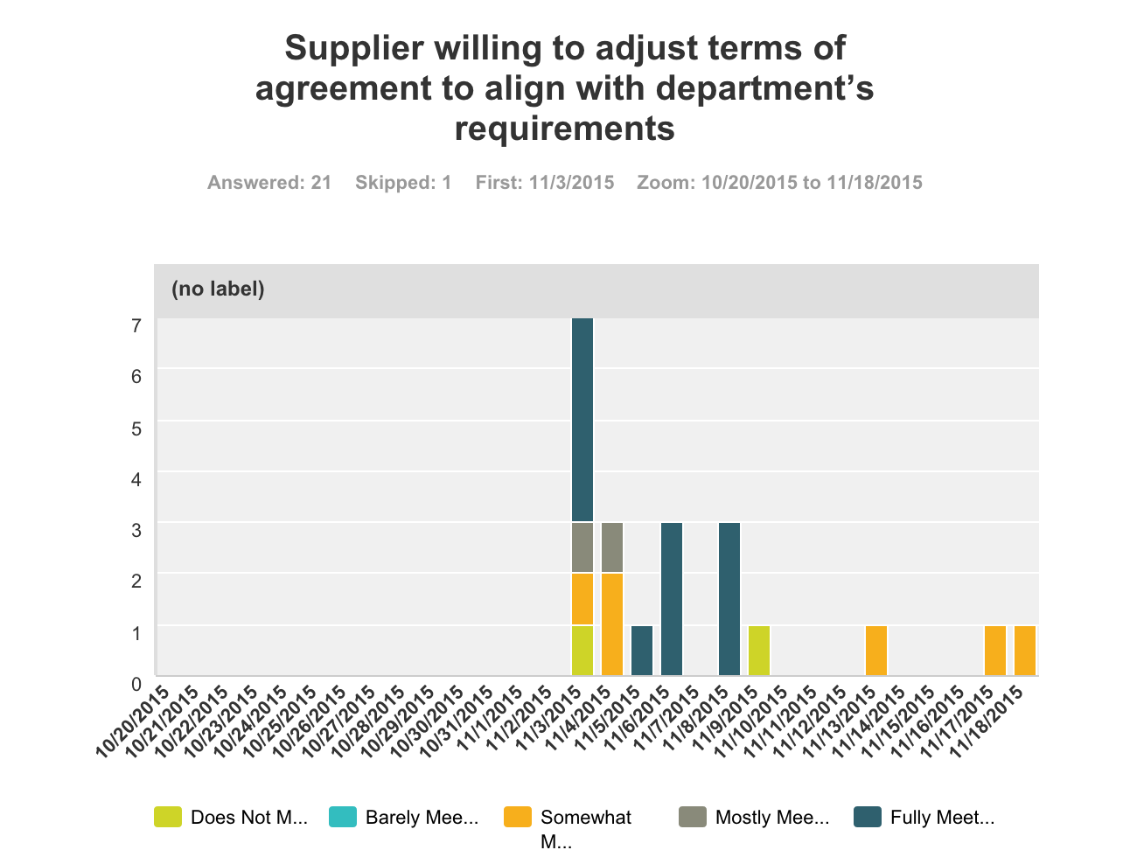

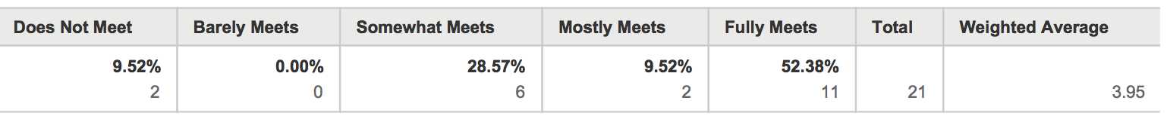

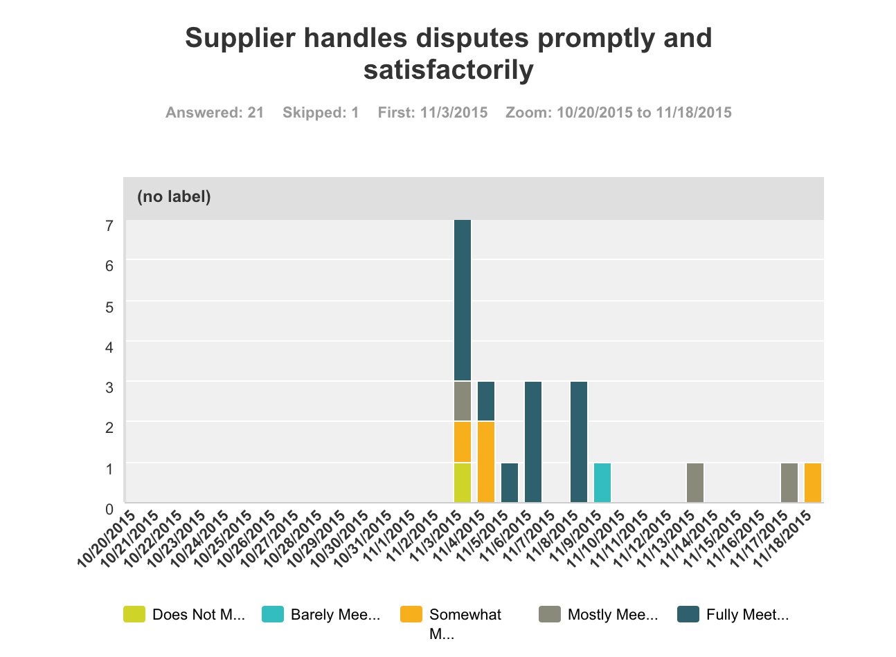

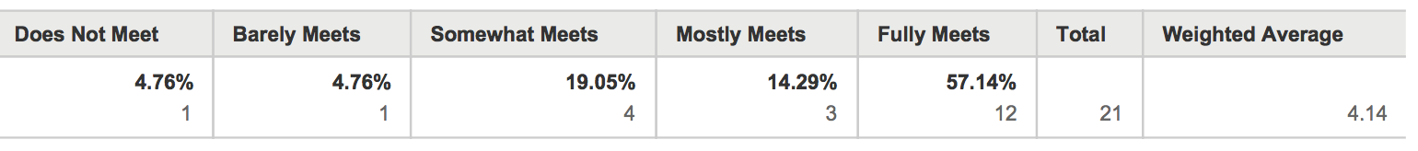

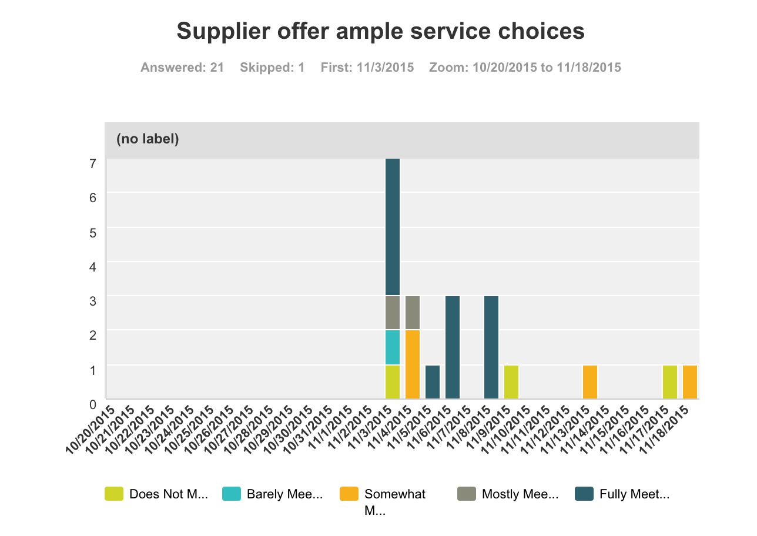

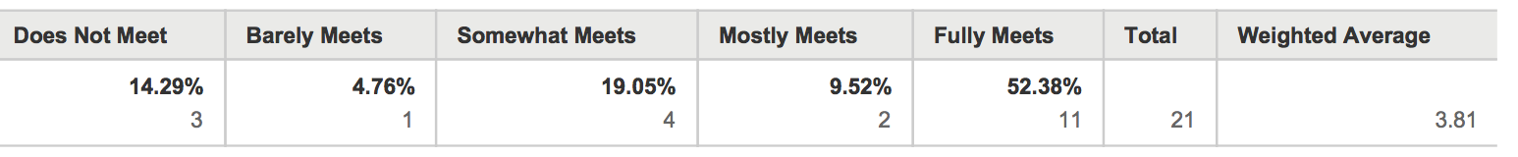

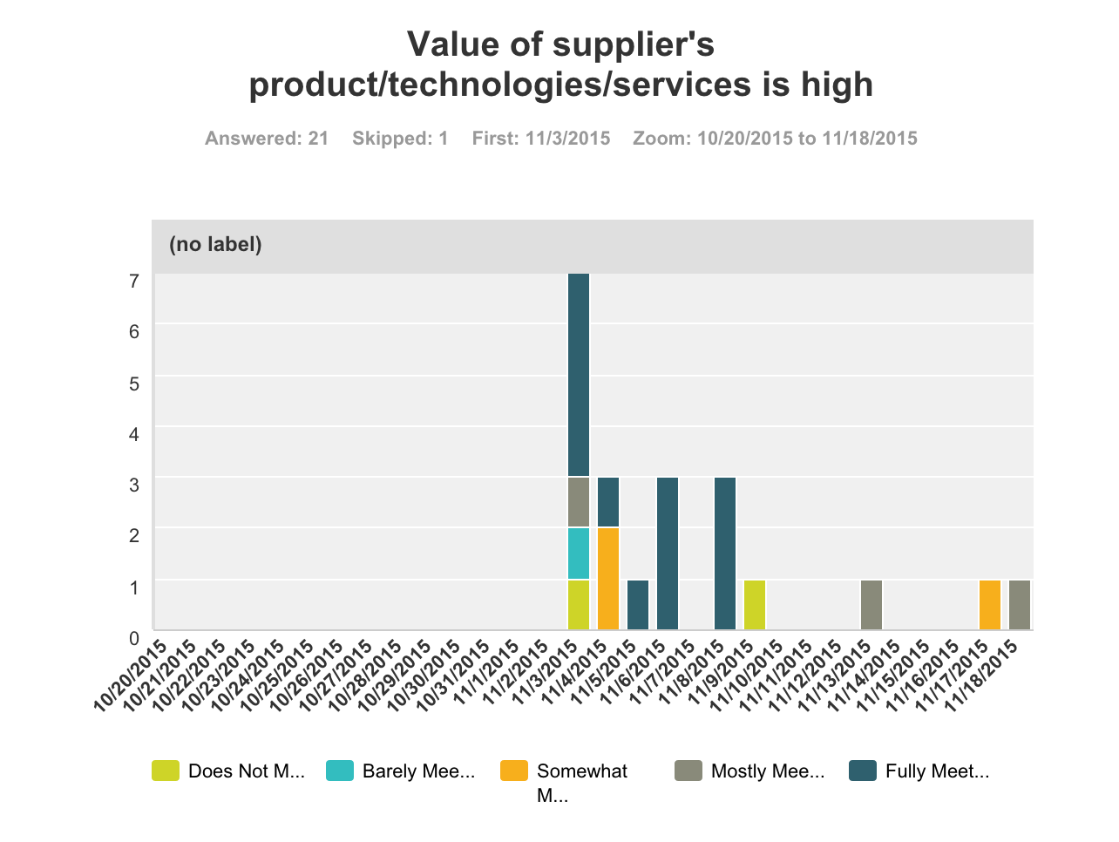

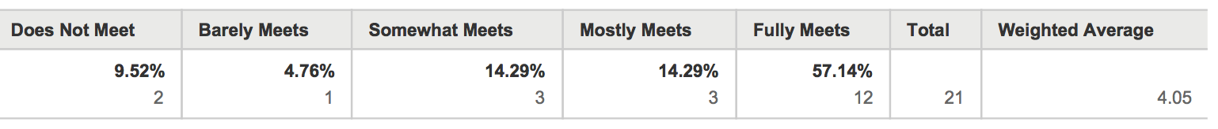

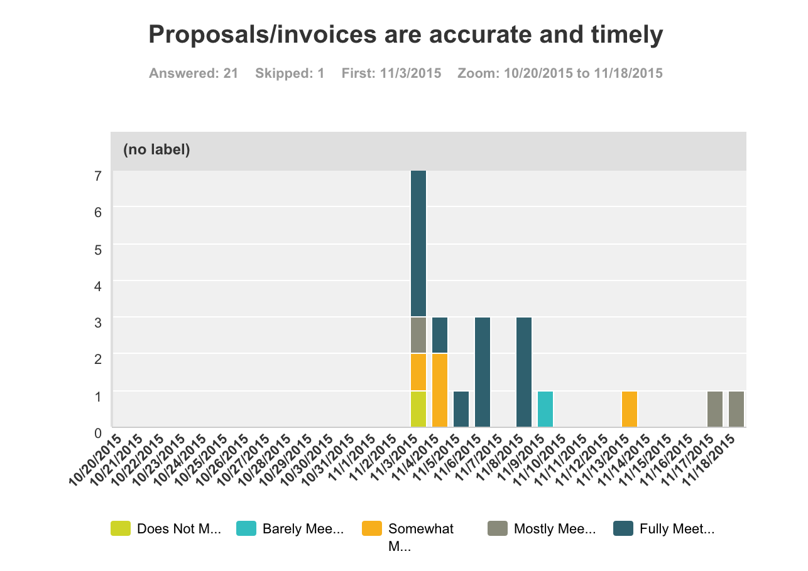

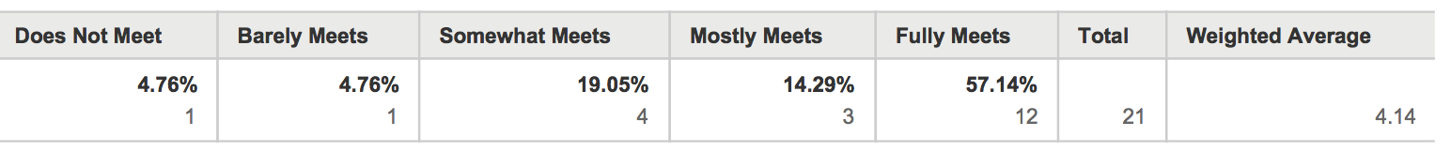

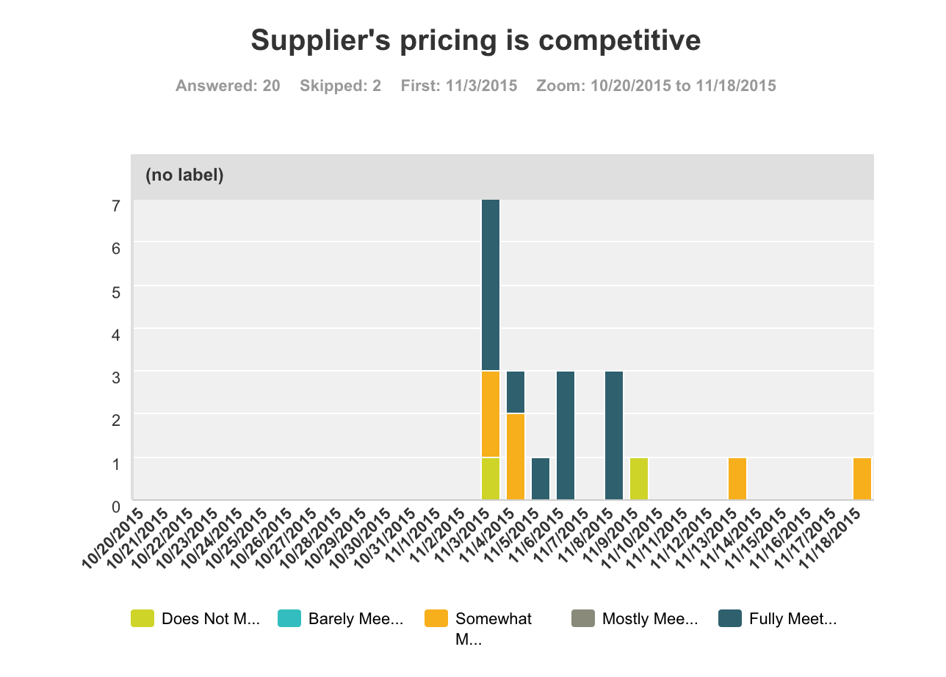

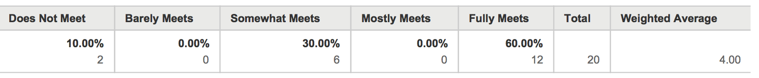

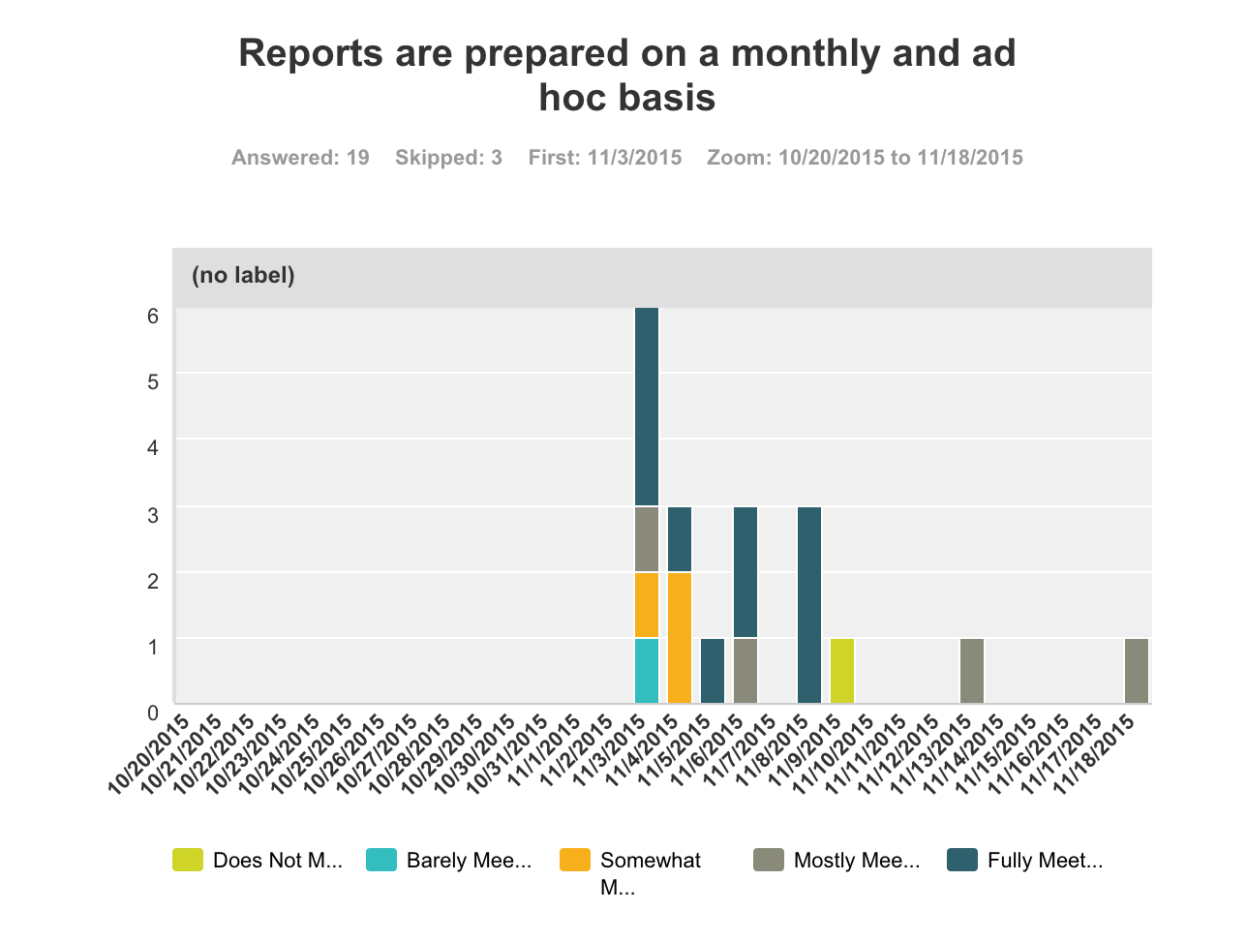

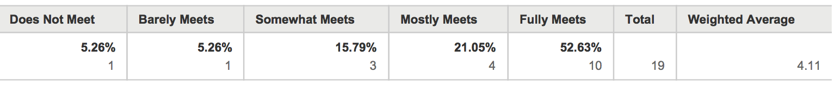

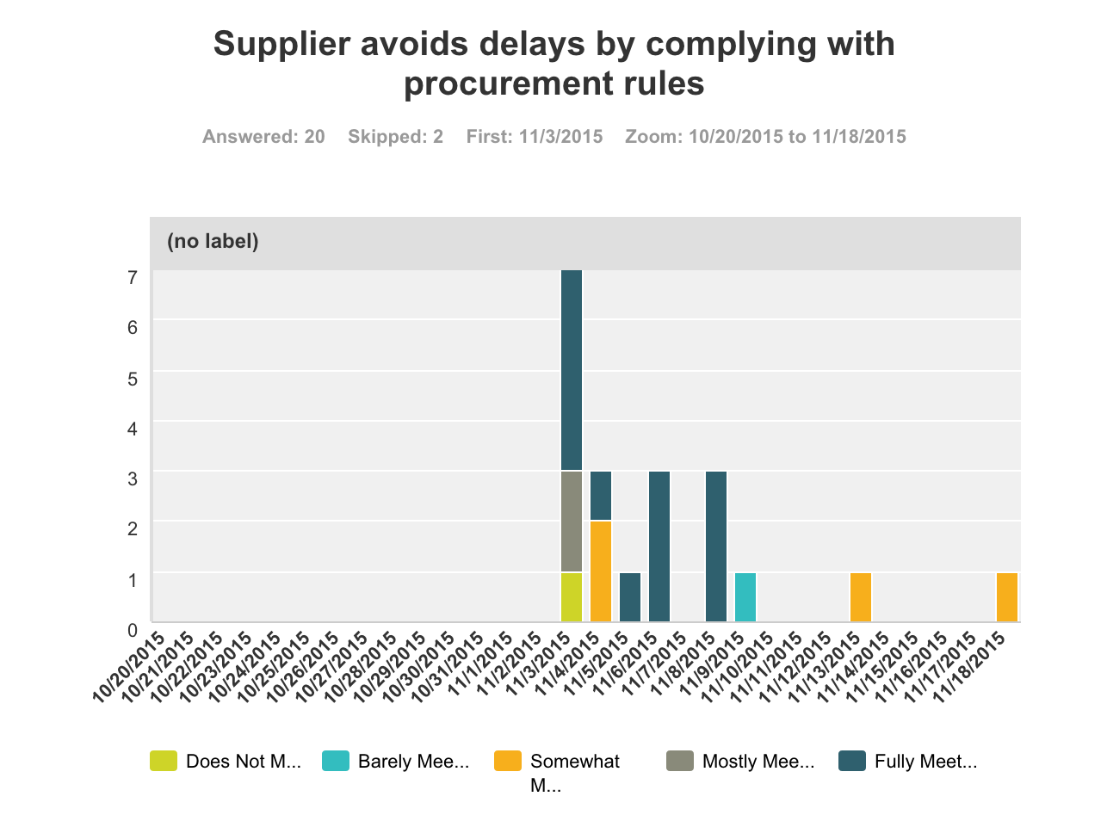

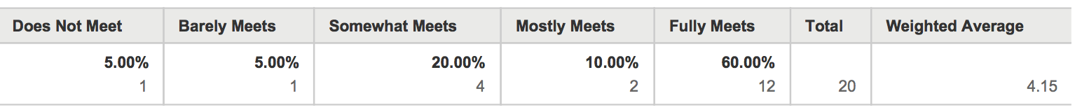

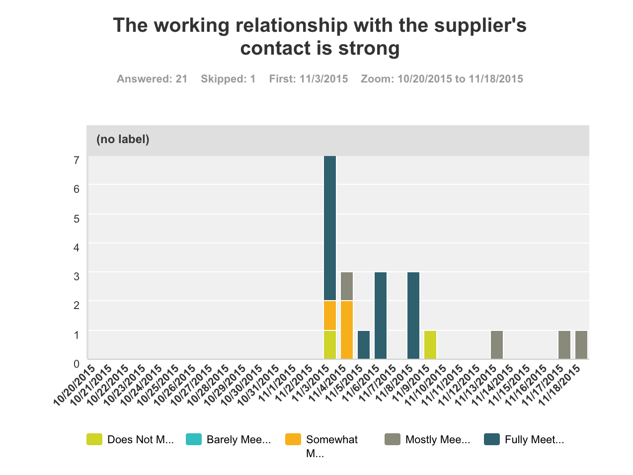

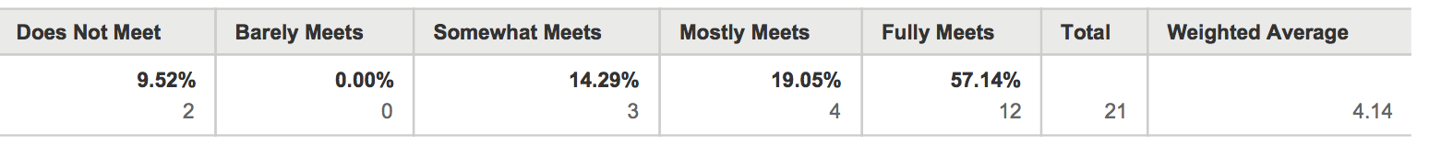

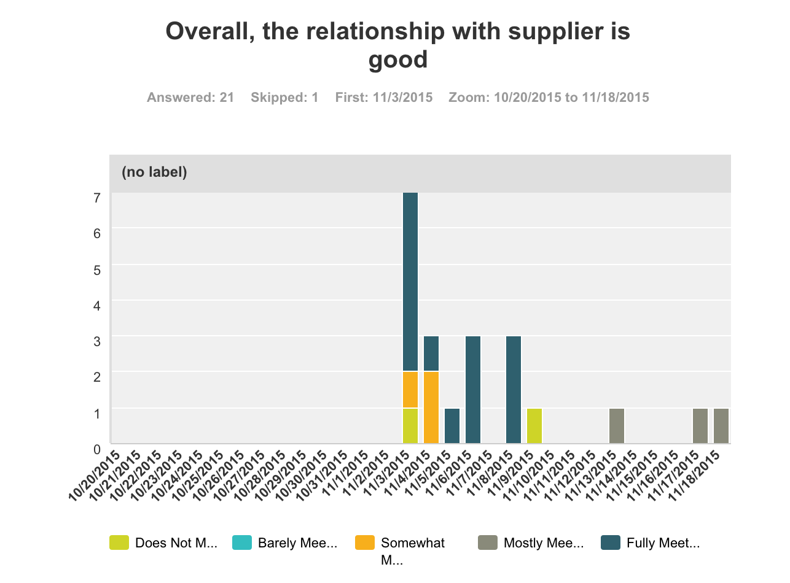

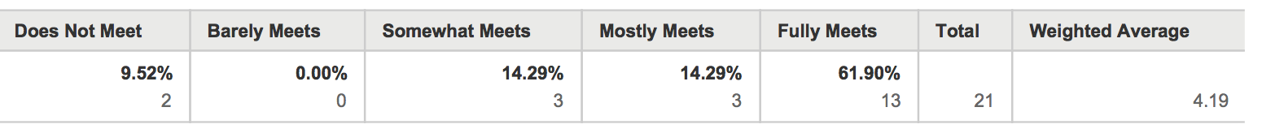

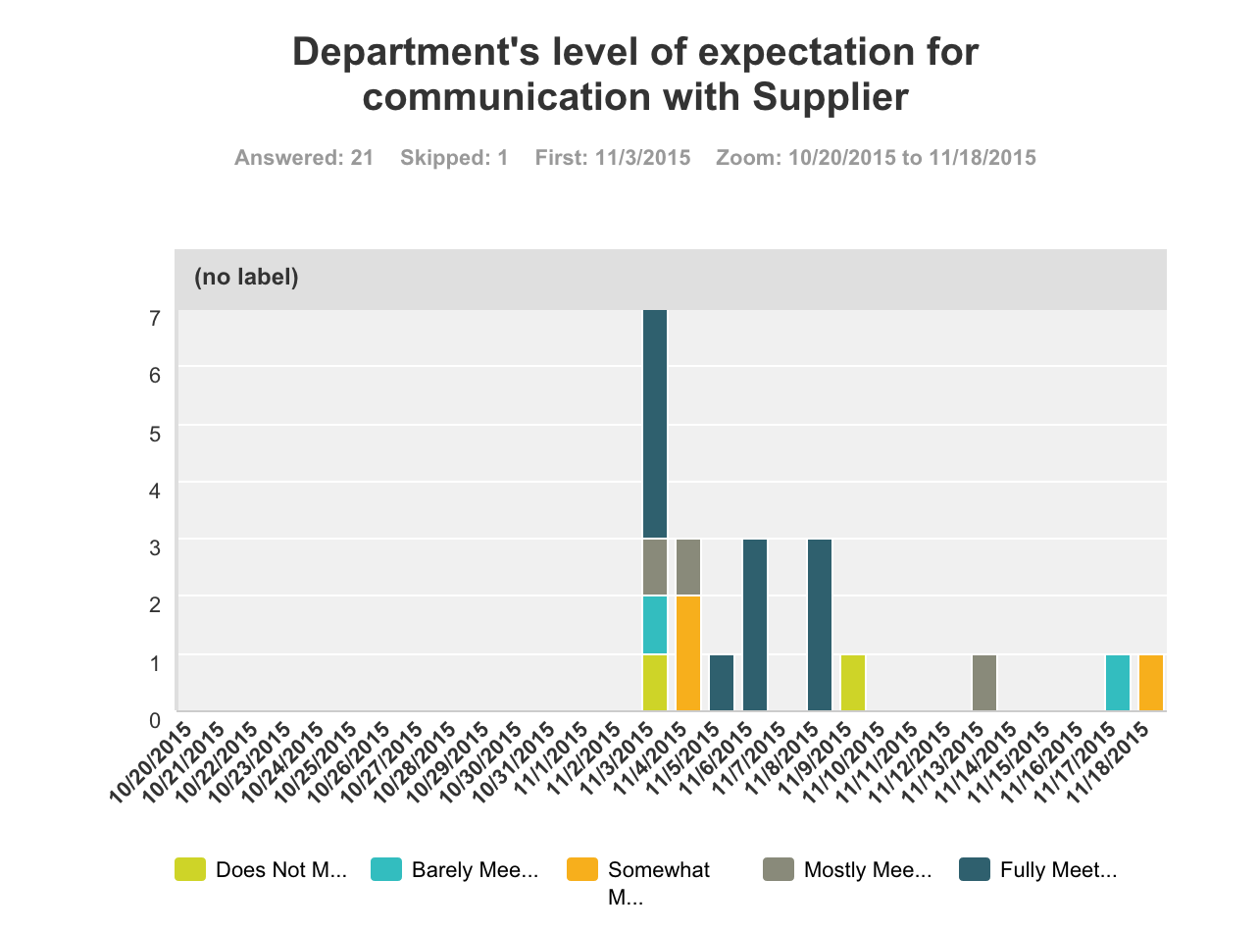

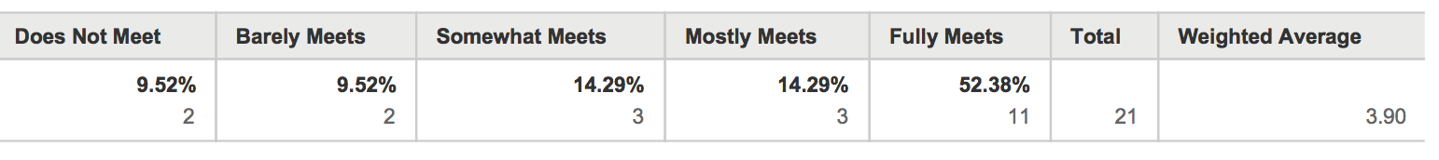

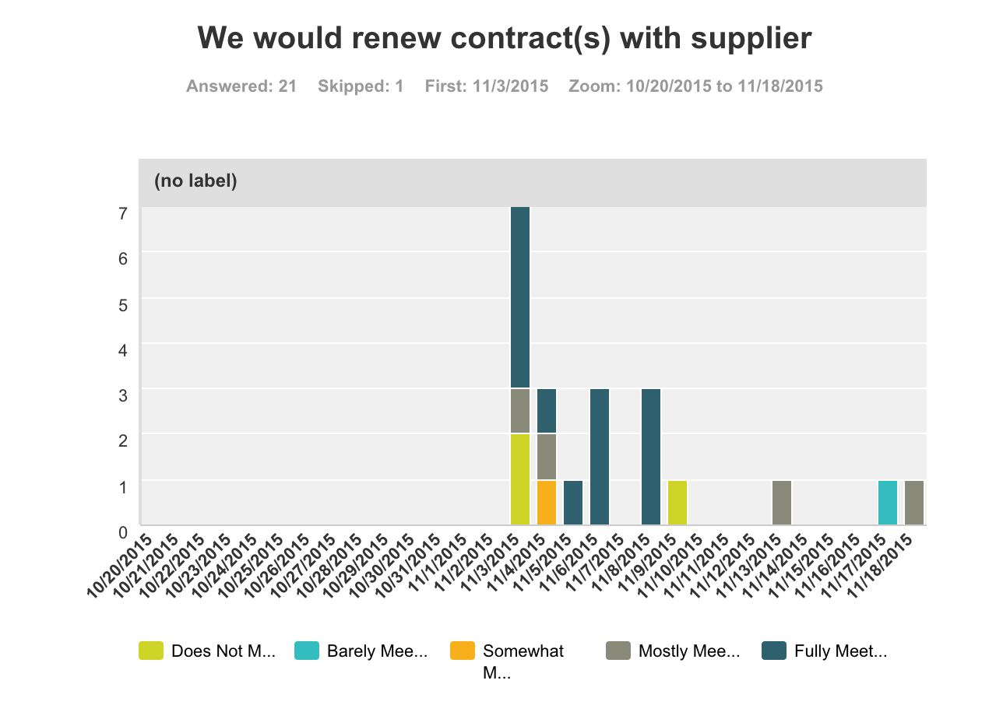

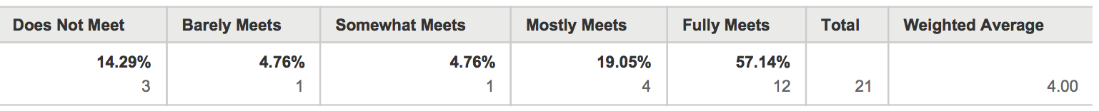

Survey Comments

Fourteen of the 22 respondents shared their comments, which are listed below.

The respondents were asked to comment on the following:

“In your own words, what are the things that you would most like to improve about this service? What are the things that you like most about this service?”

In fairness to HIC, their support team is going thru a major learning curve with understanding our priorities and our operations. That said, the most critical improvement needed now is more hands on by the support team to learn the system and our operation faster. The next thing is HIC management's active support of this team so their internal resources are more readily available to them so our tasks can be prioritized. Lastly, the need of this new team to spend more physical time at our office to learn about our business and to communicate quickly when there is anything they do not understand will accelerate the learning curve. The thing that is working best right now is the systematic "sprint" method of identifying fixes/enhancements needed and using structured accountability and scheduling to successfully complete them.

We have communicated with HIC for a significant period about our expectations/desires/goals for the project; we have shown HIC how we currently perform certain work to allow HIC understand the current operations that its work will make more efficient/needs to interface with; HIC, however, did not communicate that it may be unable to perform the work to achieve the agency's goals to develop a system that addresses user issues and to make internal operations more efficient; HIC's SOW does not accurately reflect the work; HIC's SOW is too vague about the work to be performed and the end product to the agency; HIC appears not to have considered/offered other options/models that do not involve the state portal (ehawaii.gov); on the positive, because HIC is "preapproved," the ability to select HIC without having to navigate through the procurement process for an agency that does not do procurement is an advantage; Russell Castagnaro is relatively accessible

HIC's awesome work to help our division transform a paper application into an online application, submission, and review process has been a great benefit to our division. The online application system has allowed us to receive, review, and act on application much more efficiently and has also reduced the administrative burden of having a paper application system.

HIC took the initiative to suggest and help our division develop the first mobile app among the various states with similar operations in our field. The work that HIC has done and continues to do with our division is excellent.
HIC has provided great service to our division and has helped our division to provide the public with access to information in Hawaii.

Great service. Kept us informed of the latest IT technology and was flexible enough to incorporate these latest IT technologies in their IT solutions provided.

I enjoy working with HIC. Their customers service section, which deals with the individual public users, are quick to resolve any issues presented. Their project managers and development team are responsive and able to meet our requirements.

We are extremely satisfied working with HIC on many of our service offerings. They are truly a partner to us and I do not believe, quite frankly, that we could have done all that we have done with our public facing website services and mobile apps without HIC's help and ICSD/OIMT couldn't help us either at the speed, value and quality of product delivery. Maybe HIC needs more staff as we keep them busy.

As to my knowledge everything is good.

Reliability of completing project on time and on budget

In our experience, thus far, HIC's service has been exceptional, and we have not identified any areas where improvement is needed. Their staff are professional and very capable, and their service and product is competitive and well designed.

More extensive surveys with customers to improve our services to the public. eHawaii.gov has been very responsive to our needs - our partnership with them has been very strong and effective.

The state has a sole source contract with the web portal vendor. Our Dept is small and receives lower priority for web portal services compared to the larger executive branch Depts. Would like to have an open competitive options for web portal services. Our Dept has many SOWs and this has to be further prioritized by the web vendor. Is it possible for the Dept to re-organize and create an IT-web management team that can handle all of the online projects under a single SOW. This might reduce online development and maintenance expenses. It would also provide the Dept. with experienced professional web IT managers to design and implement the appropriate online systems. Most of the Division staff that provide input into the system design and SOW do not possess the knowledge and web IT skill set to handle this job. That's why some Divisions struggle with their online projects with the web portal vendor.

They do not take responsibility for their work and work on their own time schedule instead or our time schedule. they are not responsive to our needs.

